**JOBSHEET 11**

**Perulangan 2**



**Name**

Sherly Lutfi Azkiah Sulistyawati

**NIM**

2341720241

**Class**

1I

**Department**

Information Technology

**Study Program**

D4 Informatics Engineering

Labs Activity

**Question! (Experiment 1)**

1. Jika pada perulangan for, inisialisasi **i=1** diubah menjadi **i=0**, apa yang akibatnya? Mengapa bisa demikian?
2. Jika pada perulangan for, kondisi **i <= N** diubah menjadi **i > N**, apa akibatnya? Mengapa bisa demikian? Complete the audience list in step 4 so that it looks like the following program code
3. Jika pada perulangan for, kondisi step **i++** diubah menjadi **i--** apa akibatnya? Mengapa bisa demikian?

**Answer!**

1. Perulangan akan dimulai dari 0, karena dalam pemrograman indeks dimulai dari 0.
2. Perulangan tidak akan berjalan karena pada kondisi ini tidak akan pernah terpenuhi jika i dimulai dari 1.
3. Akibatnya nilai i akan terus berkurang dan perulangan menjadi tidak terbatas karena i-- akan mengurai nilai i setiap kali perulangan berjalan.

**Question! (Experiment 2)**

1. Should the array elements from the scanner be filled in sequentially starting from the 0th index? Please explain!
2. Modify the program code to provide the following menu options:

- Menu 1: Input audience data

- Menu 2: Show audience list

- Menu 3: Exit

1. Modify the program code to handle if the seat row/column number is not available
2. In menu 1, modify the program code to give a warning if the selected seat is already occupied by other audiences, then display a command to enter rows and columns again
3. In menu 2, if the seat is empty, replace null with ***
4. Commit and push the program code to GitHub

**Answer!**

1. The decision of whether the array elements from the scanner should be filled sequentially starting from the 0th index depends on the requirements of the program and how we want to organize the data.
2. 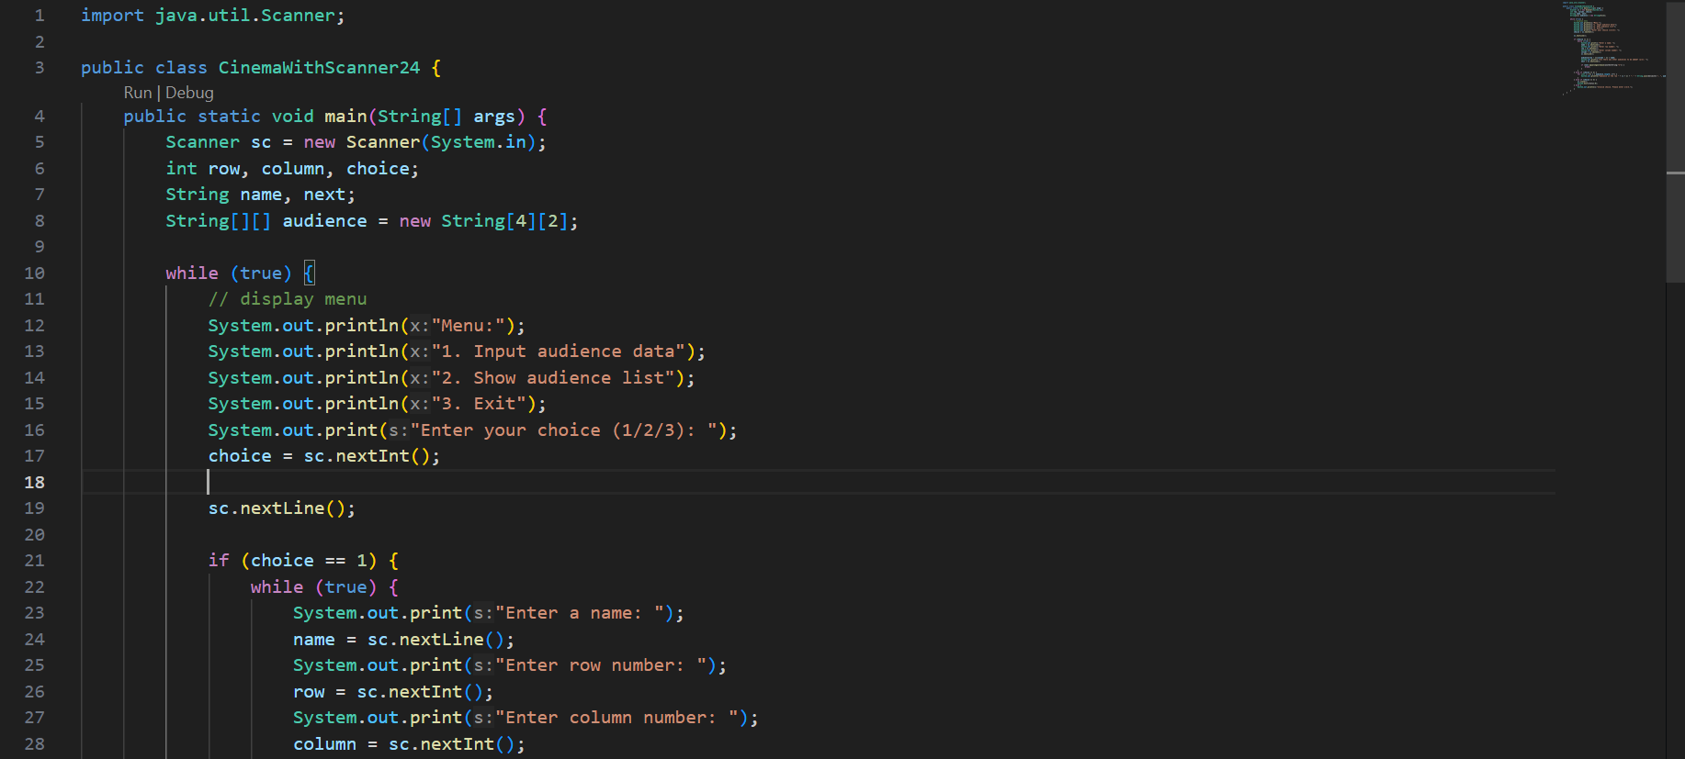
3. 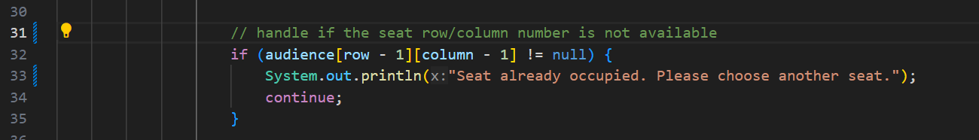
4. 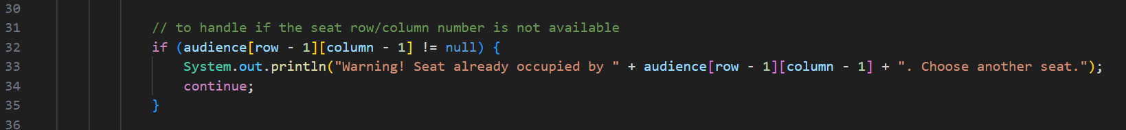
5. 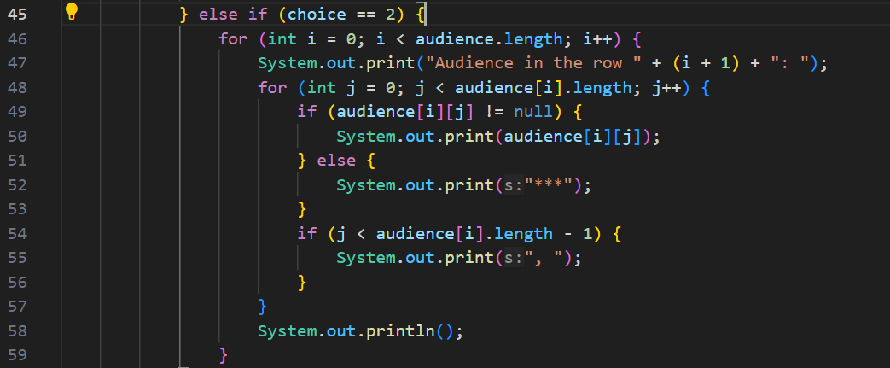

**Question! (Experiment 3)**

1. Add the following program code:

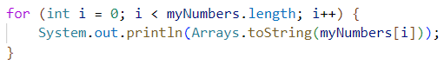

1. What is the function of Arrays.toString()?
2. What is the default value for elements in an array with the data type int?
3. Add the following program code:

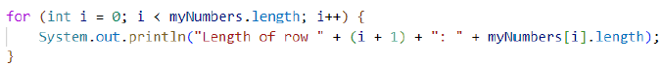

1. The myNumbers array has a different length for each row. How to make the length for each row the same? Can the array length be modified?

**Answer!**

1. 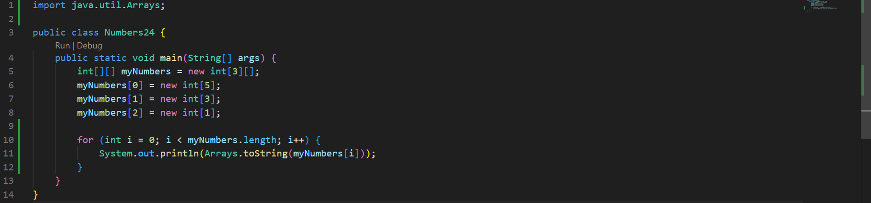
2. Arrays.toString() method is used to return a string representation of the contents of an array.
3. The default value for elements in an array of the int data type is 0. When create an array of int and do not explicitly assign values to its elements, all elements in the array will be initialized to 0.
4. 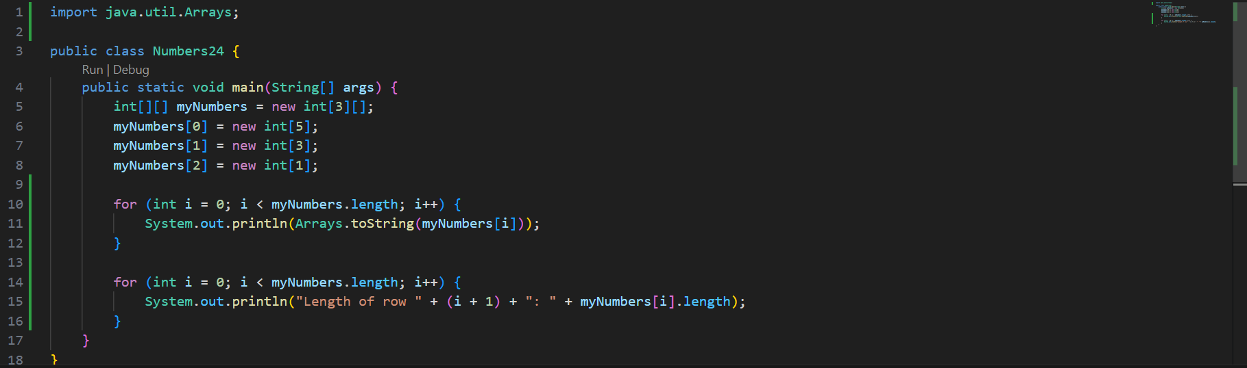
5. The length of an array is fixed at the time of its creation and cannot be modified during the program's execution. If we need to change the size of an array, we need to create a new array with the desired size and copy elements from the old array to the new one.